**DATA INSIGHTS**

**About Dataset:**

The dataset provides daily Public Transport Patronage data, distinguishing between two types of tickets: MyWay cards and paper tickets. Paper tickets purchased from Ticket Vending Machines are not included in the dataset. Special event patronage is also excluded.

**Key Variables:**

Date: Represents the date of the recorded patronage data.

MyWay: Indicates the number of passenger boardings using MyWay cards on the respective date.

Paper Ticket: Represents the number of passenger boardings using paper tickets (excluding those purchased from Ticket Vending Machines) on the respective date.

**Data Description**

Date MyWay Paper Ticket

count 396 396.000000 396.000000

mean 2023-10-15 12:00:00 48324.664141 4789.712121

min 2023-04-01 00:00:00 2345.000000 373.000000

25% 2023-07-08 18:00:00 23246.250000 2592.000000

50% 2023-10-15 12:00:00 56824.000000 4770.000000

75% 2024-01-22 06:00:00 66537.750000 6900.500000

max 2024-04-30 00:00:00 79279.000000 10154.000000

std NaN 21774.787575 2541.356289

* The dataset reveals daily trends in public transport patronage through MyWay cards and paper tickets, offering insights into passenger boarding patterns over time.
* Analysis of MyWay card versus paper ticket usage provides valuable insights into passenger preferences for ticketing methods, informing decisions on ticketing infrastructure and promotions.
* The plot allows us to visually assess any trends or patterns in MyWay card usage over time. We can identify whether there is a general increase, decrease, or stability in patronage trends.

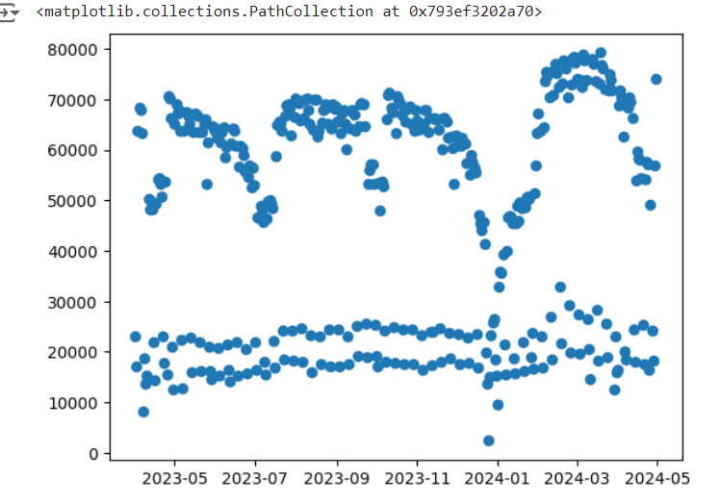

* The diagonal plots display the distributions of each variable in the dataset. These histograms provide insights into the spread and shape of the data for each variable.

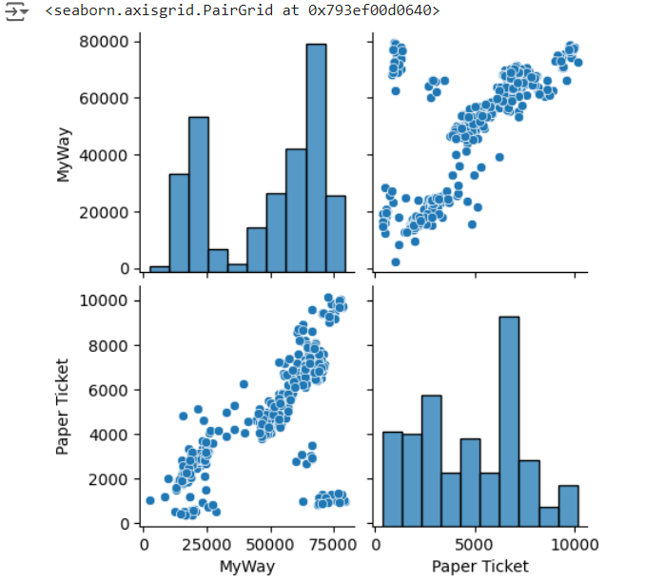

* The color intensity in the heatmap indicates the strength of the correlation between pairs of variables. Darker colors (e.g., dark red or dark blue) represent stronger correlations, while lighter colors (e.g., light yellow) indicate weaker correlations.

